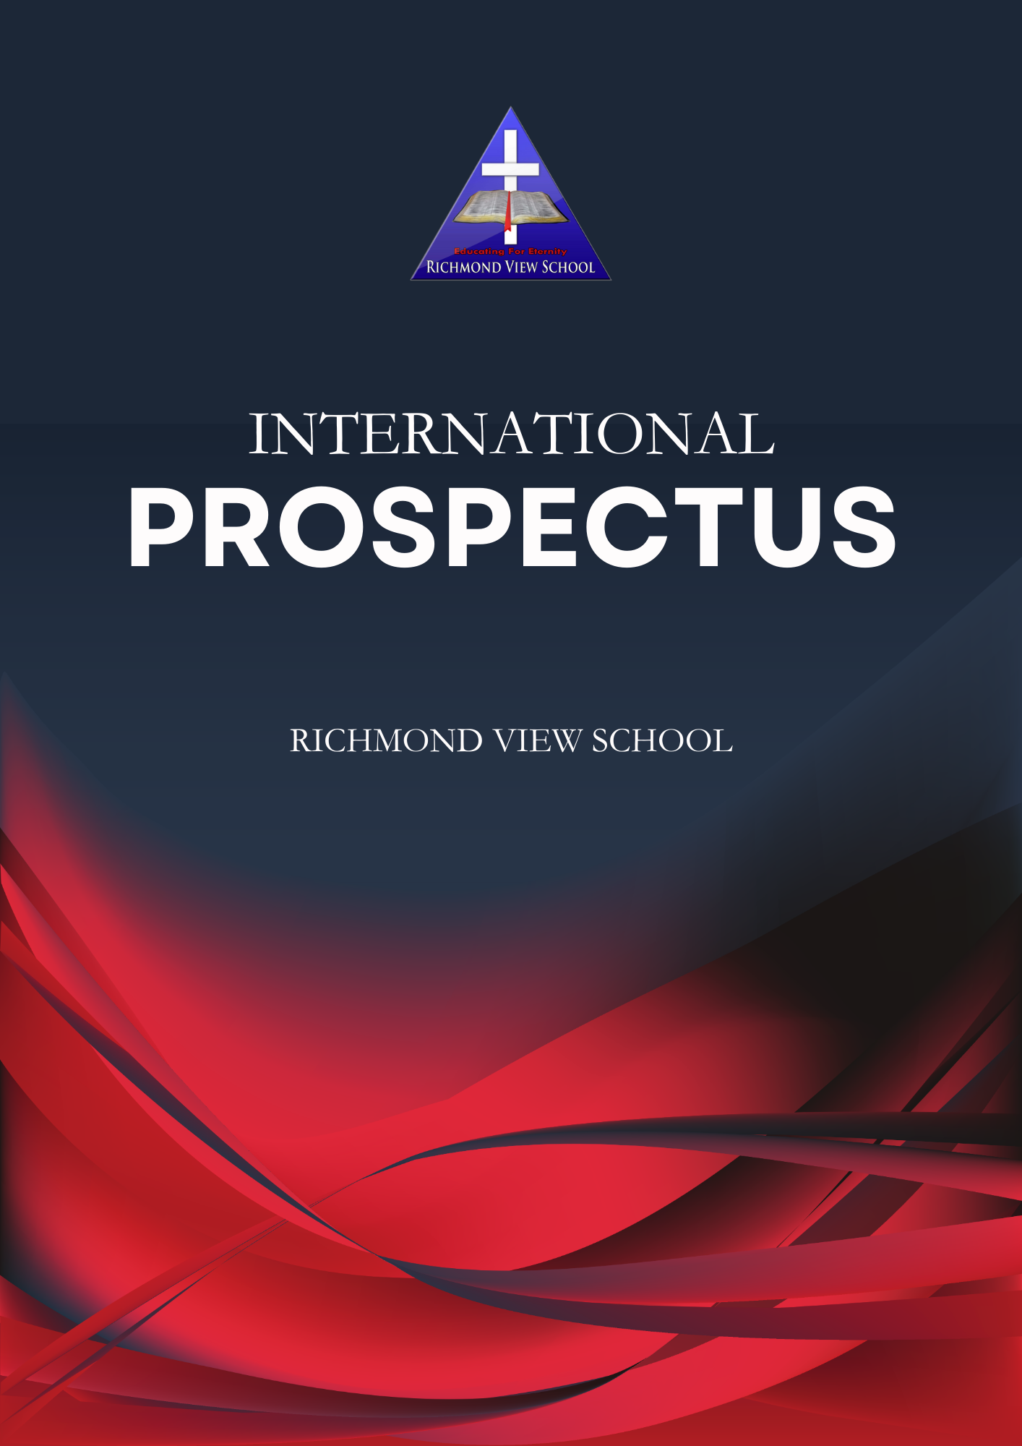
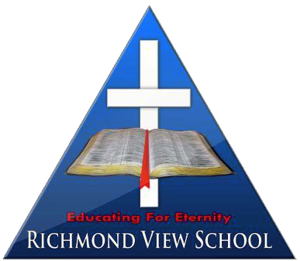
Richmond View School
INTERNATIONAL
PROSPECTUS
Educating for Eternity
INDEX
WELCOME 5
WHO WE ARE AND OUR VALUES 6
Our vision 6
Our mission 6
Our values 6
What are we learning at RVS? 7
FACILITIES ON OFFER 8
NEW ZEALAND SYSTEM AND SCHOOL EDUCATIONAL APPROACH 9
General information – New Zealand school system 9
SCHOOLING LEVELS 9
Early childhood 9
Primary schools 9
Intermediate schools 10
Secondary schools (also known as High School or College) 10
Tertiary education 10
Vocational education providers 10
Academic pathways 11
Universities 11
Te Pukenga (New Zealand Institute of Skills and Technology) 11
OUR LEARNING ENVIRONMENT 12
Inspiring each learner 12
Junior School (Years 0-6) 12
Middle School (Years 7-10) 12
Senior School (Years 11-13) 13
NCEA and subject selection for international students 13
Subjects available at Richmond View School 14
ESOL 14
Student life 15
EXTRACURRICULAR ACTIVITIES 16
Sport Academy 16
Marlborough primary schools festivals 16
The Honours Programme 16
Performing arts 17
ACCOMMODATION FOR INTERNATIONAL STUDENTS 18
Homestay family 18
Parents and designated caregivers 18
SUPPORT FOR INTERNATIONAL STUDENTS 19
Meet our international team 19
Support services 19
Counselling and Wellbeing, Guidance Counsellor 19
APPLICATION PROCESS AND REQUIREMENTS 20
FEES FOR INTERNATIONAL STUDENTS 21
International fee schedule 2025 21
HELPFUL LINKS 22

WELCOME
Welcome International Students to Richmond View School (RVS), a vibrant, supportive community where every student is valued for their individuality and where they are encouraged to pursue excellence, using the gifts God has provided.

If you have decided to come to Richmond View School or are still in the process of making a decision, may you be blessed during the process, regardless of the outcome. We consider our school rich for its cultural diversity, with many different cultures represented in our community. I believe you will feel at home in our caring community and be included as family.

We see our role as a partnership between school and family to develop the whole person through educational, spiritual, social and recreational pursuits. Our focus is on equipping students to find who God created them to be, and we provide a range of engaging co-curricular activities such as sport, music, drama, and outdoor education to complement academic study. These meaningful pursuits help students develop important skills, such as interpersonal and social skills, physical fitness, learning about leadership and working as members of a team.

As you read through the documentation, I hope you see the heart that we have for young people, their growth and reaching their potential. We are proud of our faith-rich and student-focused learning community and look forward to having you as a part of it.



Tom Jarrett
Principal
Richmond View School

WHO WE ARE AND OUR VALUES
Richmond View School is a State-Integrated Special Character School between the Years 0-13, serving the Christian community of Marlborough.

Our vision
'Educating for Eternity'

Our mission
Within the framework of a Christian Worldview, Richmond View School will provide an excellent education that equips each student for their future.

Our values
- Love for God
- Love for self and others
- Respect for God's creation
- Faith, Hope, Humility
- Integrity, Excellence & Perseverance

What are we learning at RVS?

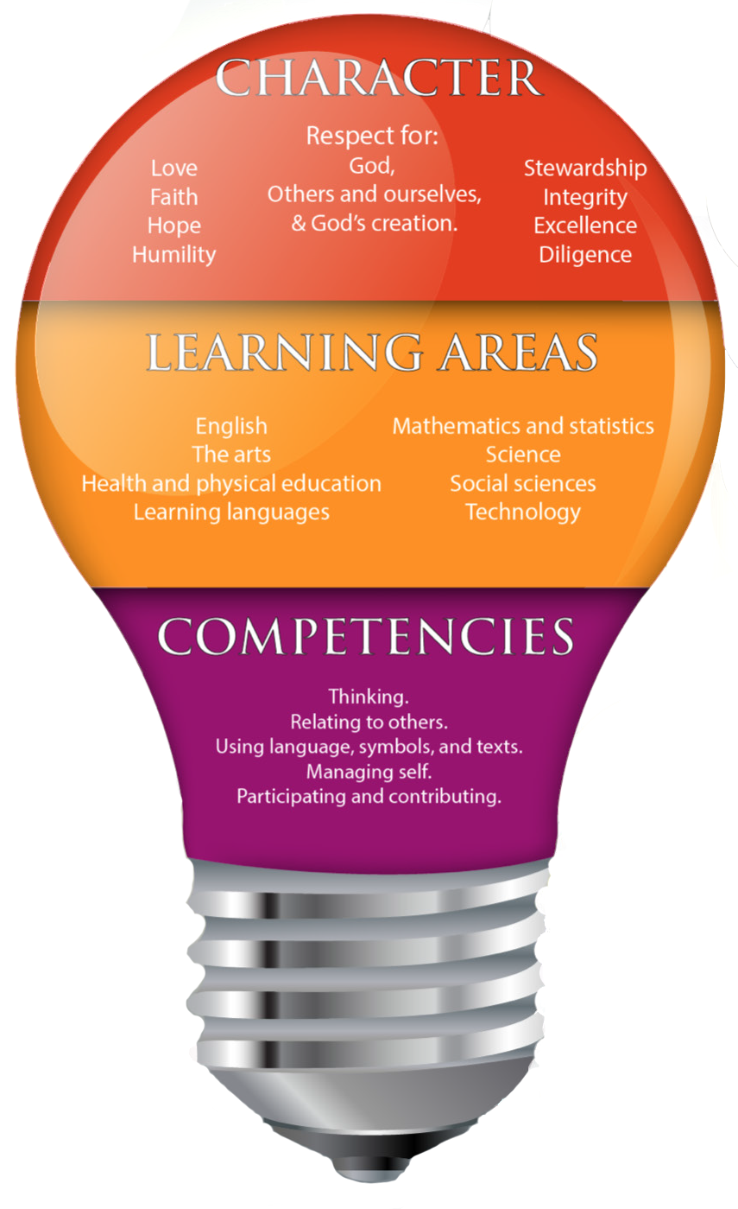

FACILITIES ON OFFER
Richmond View School is located in a picturesque setting by the Taylor River. The school is situated on the same grounds as Blenheim’s Elim Church. Our campus is continually expanding and improving, and now includes the following facilities:

- Auditorium
- Specialised and flexible learning spaces across Junior, Middle and Senior Schools
- Library
- Science Lab
- Art Room
- Specialist Hospitality Classroom
- Playgrounds and two basketball courts
- Two sports ovals

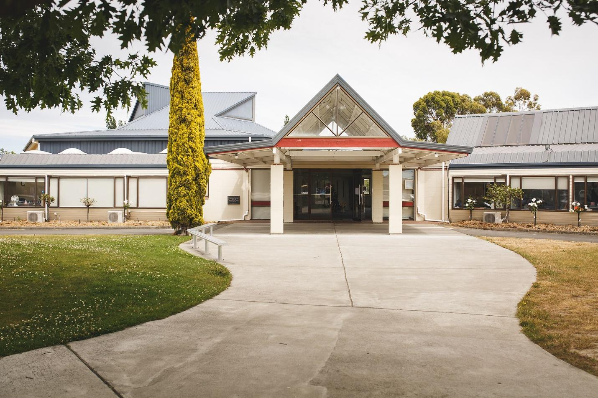

NEW ZEALAND SYSTEM AND SCHOOL EDUCATIONAL APPROACH

General information – New Zealand school system
The New Zealand national curriculum is not strictly tied to year, level, or age. The New Zealand curriculum levels represent a stage of learning because each student's rate of learning is different. Students progress when ready from one level to the next, and when they have achieved the skills, knowledge and understanding required for a level. Teachers teach students at different levels in their classes.

Schooling Level | Years/Grades | Age
Early childhood | Pre-school | Birth to 5 years
Primary School | Years 1 to 8 | 5 years to 13 years
Intermediate School | Years 7 to 8 | 11 years to 13 years
Secondary School | Years 9 to 13 | 12 or 13 years to 17 or 18
Tertiary | University or similar | 17 onwards

Richmond View School is a State-Integrated Special Character School serving the Christian community from years 1 to 13.

SCHOOLING LEVELS

Early childhood
Provides education and care for children before they are old enough to go to school. New Zealand has more than 4000 licensed early childhood education services available, these include play centres, kindergartens, childcare centres, playgroups and home-based care.

Primary schools
Students will study subjects guided by the New Zealand National Curriculum such as English, languages, mathematics and statistics, science, the arts, health and physical education, social sciences and technology. Students are assessed regularly for abilities in reading, writing and mathematics against expectations as set out in The New Zealand National Curriculum for their age level.

Intermediate schools
Primary education starts at Year 1 and continues through to Year 8. Years 7 and 8 are offered either at a primary school or at a separate intermediate school. Intermediate schools are a bridge between primary school and secondary school.

Secondary schools (also known as High School or College)
Students at secondary schools work towards the National Certificate of Educational Achievement (NCEA). NCEA is New Zealand’s national qualification for senior secondary students. It is regarded as the pathway for employment and tertiary studies. NCEA exams are recognised throughout the world at many universities and high schools. Secondary schools also offer some vocational subjects, such as hospitality, travel and tourism.

New Zealand has three types of secondary schools:
- state schools, where 85% of New Zealand children go.
- state-integrated schools can be primary, intermediate, or secondary, the New Zealand Curriculum is taught, schools have their own special character as part of their school programme and the school’s buildings and land are privately owned.
- private schools (independent) can be primary, intermediate, or secondary. They don’t have to follow the New Zealand Curriculum, but their learning programme must be of the same quality.

International Students in Years 11 to 13 at Richmond View School for the full academic year, beginning January/February to December, may be required to sit NCEA exams. These are at the end of the year, in November and December. For more information on NCEA, please refer to
https://www2.nzqa.govt.nz/international/study-nz-quals/

Tertiary education
Universities
New Zealand has eight state-funded universities. Universities offer higher degree-level education. Programmes are research-led and generally academic rather than vocational. ITPs and a few larger PTEs offer vocational degree-level education.
Link to the “Universities New Zealand” website

Vocational education providers
Te Pūkenga is New Zealand’s largest vocational education provider. Te Pūkenga includes New Zealand’s 16 Institutes of Technology and Polytechnics (ITPS) along with 9 Industry Training Organisations.
Link to “Te Pūkenga” website

Choose the type of institution that’s best for your career path. Visit this website for more information.
https://www.studyinnewzealand.govt.nz/why-nz/education-system

Academic pathways
When International students graduate from Secondary School, many choose to continue their studies in New Zealand. There are eight universities in New Zealand, as well as numerous institutes and polytechnics for those wishing to further their studies.

Universities
- Auckland University of Technology
- Lincoln University
- Massey University
- University of Auckland
- University of Canterbury
- University of Otago
- University of Waikato
- Victoria University of Wellington

Te Pukenga (New Zealand Institute of Skills and Technology)
- Ara Institute of Canterbury
- Eastern Institute of Technology (EIT)
- Manukau Institute of Technology
- Nelson Marlborough Institute of Technology (NMIT)
- North Tec
- Otago Polytechnic
- Southern Institute of Technology
- Tai Poutini Polytechnic
- Toi Ohomai Institute of Technology (TOI-OHOMAI)
- Waikato Institute of Technology
- Wellington Institute of Technology (Weltec)
- Whitireia New Zealand(Whitireia NZ)
- UCOL – University College of Learning

For more information on tertiary education available in New Zealand, visit:
https://nzedu.com.sg/new-zealand-universities-and-polytechnics/

OUR LEARNING ENVIRONMENT

Inspiring each learner
At RVS, we see students as individuals created by God and recognise their unique culture, whanau, passions, struggles and strengths. Their learning environment is designed to encourage their active engagement and develop in them an understanding of their own activity as learners.

The school has a variety of flexible creative spaces within which they can learn, and incorporates diverse teaching approaches, learning opportunities and resources to cater for personal learning needs and promote creativity.

We understand that students learn best within a social framework, and thus we encourage strong positive relationships between teachers, peers and family in a caring and nurturing learning environment.

RVS sets high expectations for both the educational and social development of students. Teachers work in partnership with parents to set goals unique to each student’s needs. Students are also encouraged to provide feedback on their learning experience to help shape future learning opportunities.

Junior School (Years 0-6)
The focus of the curriculum in Junior School is to ensure students experience a rich, personalised and authentic learning journey within individual, small group and large group contexts. Critical and applied deep thinking skills are emphasied with the aim to develop self-regulated Learners.

We have richly developed programmes, that strengthen literacy and numeracy while exploring sciences and arts. The New Zealand curriculum is woven into the Interact Curriculum, which approaches the New Zealand Curriculum within a Biblical framework. Technology is a tool that has an integral role in shaping the learning environment, and our students are exposed to a variety of cutting-edge technologies.

RVS has a high staff-to-student ratio to ensure optimal support for each learner. Our teacher aides are flexible, well-trained and are an integral part of students’ learning support.

Middle School (Years 7-10)
Students in Middle School study the essential learning areas of English, Mathematics, Social Studies, Science and PE/Health. In Years 7-9, students also study Technology and Arts subjects.
As they journey through Middle School, students begin to specialise in their programme of study, commencing a broader curriculum programme in Year 10 in addition to their core studies.
This broad-based curriculum enables students to make informed choices when moving into Senior School, where their programme becomes specialised according to future aspirations.

Senior School (Years 11-13)

NCEA and subject selection for international students
The National Certificate of Educational Achievement (NCEA) is New Zealand’s national qualification for senior secondary pupils and is part of the National Qualifications Framework. It costs $383.30 for international students. It provides the pathway to tertiary education and to workplace training. You can find out more about NCEA at the NZQA website.

NCEA Level 1 (normally in Year 11)
- All Year 11 pupils take 6 subjects.
- You must take English, Mathematics, Science, PE and Health, and Christian Living.
- You must choose 2 additional options from the subjects listed below.
- Assessment is both Internal and External.
- Assessment may be either Unit Standards or Achievement Standards, or a mix of both.

NCEA Level 2 (normally in Year 12)
- All Year 12 pupils take 6 subjects and have periods set aside for study and our Health programme.
- You must take English, Mathematics and Christian Living.
- You must choose 3 additional options from the subjects listed below.
- Assessment is both Internal and External.
- Assessment may be either Unit Standards or Achievement Standards or a mix of both.

NCEA Level 3 (Normally at Year 13)
- The only compulsory subject at Year 13 is Christian Living.
- It is usual for Year 13 pupils to study 5 subjects, and have periods set aside for study and our Health programme.
- Year 13 pupils may take courses from Level 1-3.
- Students should consider prerequisites for tertiary study while deciding on their courses.
- Year 13 students should choose 5 subjects from the subject list below.
For help with making their subject choices, students should meet with their homeroom teacher, the Associate Principal of Senior School, the head of Careers, Gateway and Trades, or the International Student Director.

Subjects available at Richmond View School
Other subjects may be negotiated with the Associate Principal in charge of the Senior School.
Level 1 | Level 2 | Level 3
English
Mathematics |  | Mathematics with Calculus  Mathematics with Statistics
Science | Physics  Chemistry  Biology | Physics  Chemistry  Biology
Biblical Studies
Business Studies
Commerce/Economics
Performing Arts - comprised of Drama and Music options
 | Gateway and Work Experience
Geography
Hospitality
Languages - Japanese
Languages - Te Reo
Media Studies
Physical Education
 | Psychology
 | Trades Academy
Visual Arts

ESOL
The ESOL (English for Speakers of Other Languages) programme teaches English to people whose first language is not English, but who live in an English-speaking country and require English to communicate in daily life. At RVS, our students are required to communicate and study in English, and the ESOL programme is designed to support students at their level through differentiated programmes delivered in small group settings and in the classroom.

Student life
Richmond View School provides you with not only a first-class education but also a unique community within which you can thrive. You will experience academic growth, athletic pursuits, artistic exploration, and cultural enrichment, all while being supported by our faith-filled Christian staff members who are dedicated to providing a safe emotional environment for you to discover the world.

In the RVS environment, the focus is not only on blending these aspects and opportunities but also on the importance of our core values of respect for God, for self and others, and for God’s creation. RVS provides the opportunity for you to experience strong and healthy relationships amongst students, teachers and families within an environment that fosters positive self-esteem, a sense of self-worth and respect.

At RVS, you will have the opportunity to participate in sports competitions, take advantage of music, arts, cultural opportunities, and academia, and engage in community service initiatives. All students at Richmond View School are encouraged to explore their passions while also making meaningful connections between faith and learning, considering the impact of their actions in the community and on a global scale.

EXTRACURRICULAR ACTIVITIES

Sport Academy
The RVS Sport Academy is designed to provide a comprehensive range of sporting opportunities both within the school environment and as extracurricular activities. RVS supports students in three different ways:
- Through the curriculum
- Through RVS-organised sporting teams
- Through regional sporting opportunities. RVS works with other schools and Sports Tasman to ensure our students have access to a variety of sporting opportunities.

The Academy seeks to promote excellence in skills and physical abilities while developing character, social relationships and sportsmanship that reflect the Christian ethos of RVS.

Seasonal sports include:
- Summer Soccer
- Netball (junior and senior team)
- Touch rugby (Term 4)
- Tennis
- Volleyball​
- Hockey
​
Students may also participate in one-day sporting events, such as cricket, golf, tackle rugby and ripper rugby.

Marlborough primary schools festivals
Marlborough primary schools arrange various festivals throughout the year of a cultural or sporting nature. Sports include athletics, gymnastics, cross country and duathlon. Parents will be informed when Richmond View School participates.

The Honours Programme
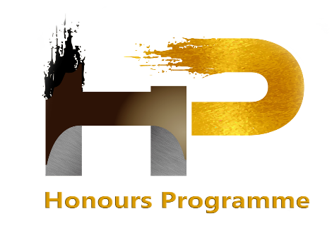
The students at Richmond View School are diverse and embody many God-given potential capabilities. While we are a small school, we aim to offer as many opportunities for growth as we can. The word ‘Honours’ implies the ‘over and above’ nature of these activities. These are opportunities that sit outside of curriculum work and are undertaken by students of their own volition. Within our three Honours areas of Bronze (Year 5/6), Silver (Year 7-10) and Gold (Year 11 - 13) we have our own recognition badges in four different discipline areas, Move, Serve + Lead, Create, Think and Individual badges and pursuits which may have their own award systems, (e.g. Science and Maths Badges). The Honours programme aspires to give students an opportunity to display and extend their God-given talents and passions.

Performing arts
A musical production is held every second year and is staged in our auditorium. This is a wonderful opportunity for students to experience being involved in a stage production, and for many, it provides an avenue to discover hidden talents.

During alternate years, a Talent Quest ‘Shine’ is held. Shine focuses largely on Arts and technology, and often includes, but is not limited to the following:
- Painting​
- Drawing
- Dancing
- Singing
- Instrumental performance
- Speech
- Drama

Other avenues for performance​ include:
- Assemblies
- Zest Media
- Music Academy performances

RVS students in years 9-13 also have the opportunity to perform in the combined colleges' productions in the ASB Theatre. A professional-quality, 700-seat auditorium.

Marlborough has a rich variety of performing arts opportunities, including choirs, local orchestras and regional productions.

If there is anything you think that your child would like to participate in while in New Zealand and it’s not listed on the list above, please don’t hesitate to ask our International Student Director to see if they can advise you on other opportunities that may exist in Marlborough.

ACCOMMODATION FOR INTERNATIONAL STUDENTS

Homestay family
Richmond View School facilitates the process of finding a suitable homestay family for any International Student. Host Families are carefully chosen so students are close to school and have easy access to public transport, local shops and amenities.

Homestay families provide three meals a day and provide a caring home where students are part of their family life. Host families provide support and care for them while they are in New Zealand. Students often form lifelong friendships with their host families.

Before a student departs from their home country, details of their host family will be sent to them. Students are greeted at the airport when they arrive in New Zealand.

Our International Department staff provide care and support for all International Students and their homestay families.

Parents and designated caregivers
Our International Department is also responsible for ensuring students who are staying with their parents, homestay families or designated caregivers (relatives or close friends of parents), have living conditions that comply with the Code of Practice requirements.

SUPPORT FOR INTERNATIONAL STUDENTS

Meet our international team
Our dedicated team is here to ensure the well-being and support of every international student who chooses to study with us at Richmond View School. Your well-being and success are our top priorities. We are excited to join you on your journey.

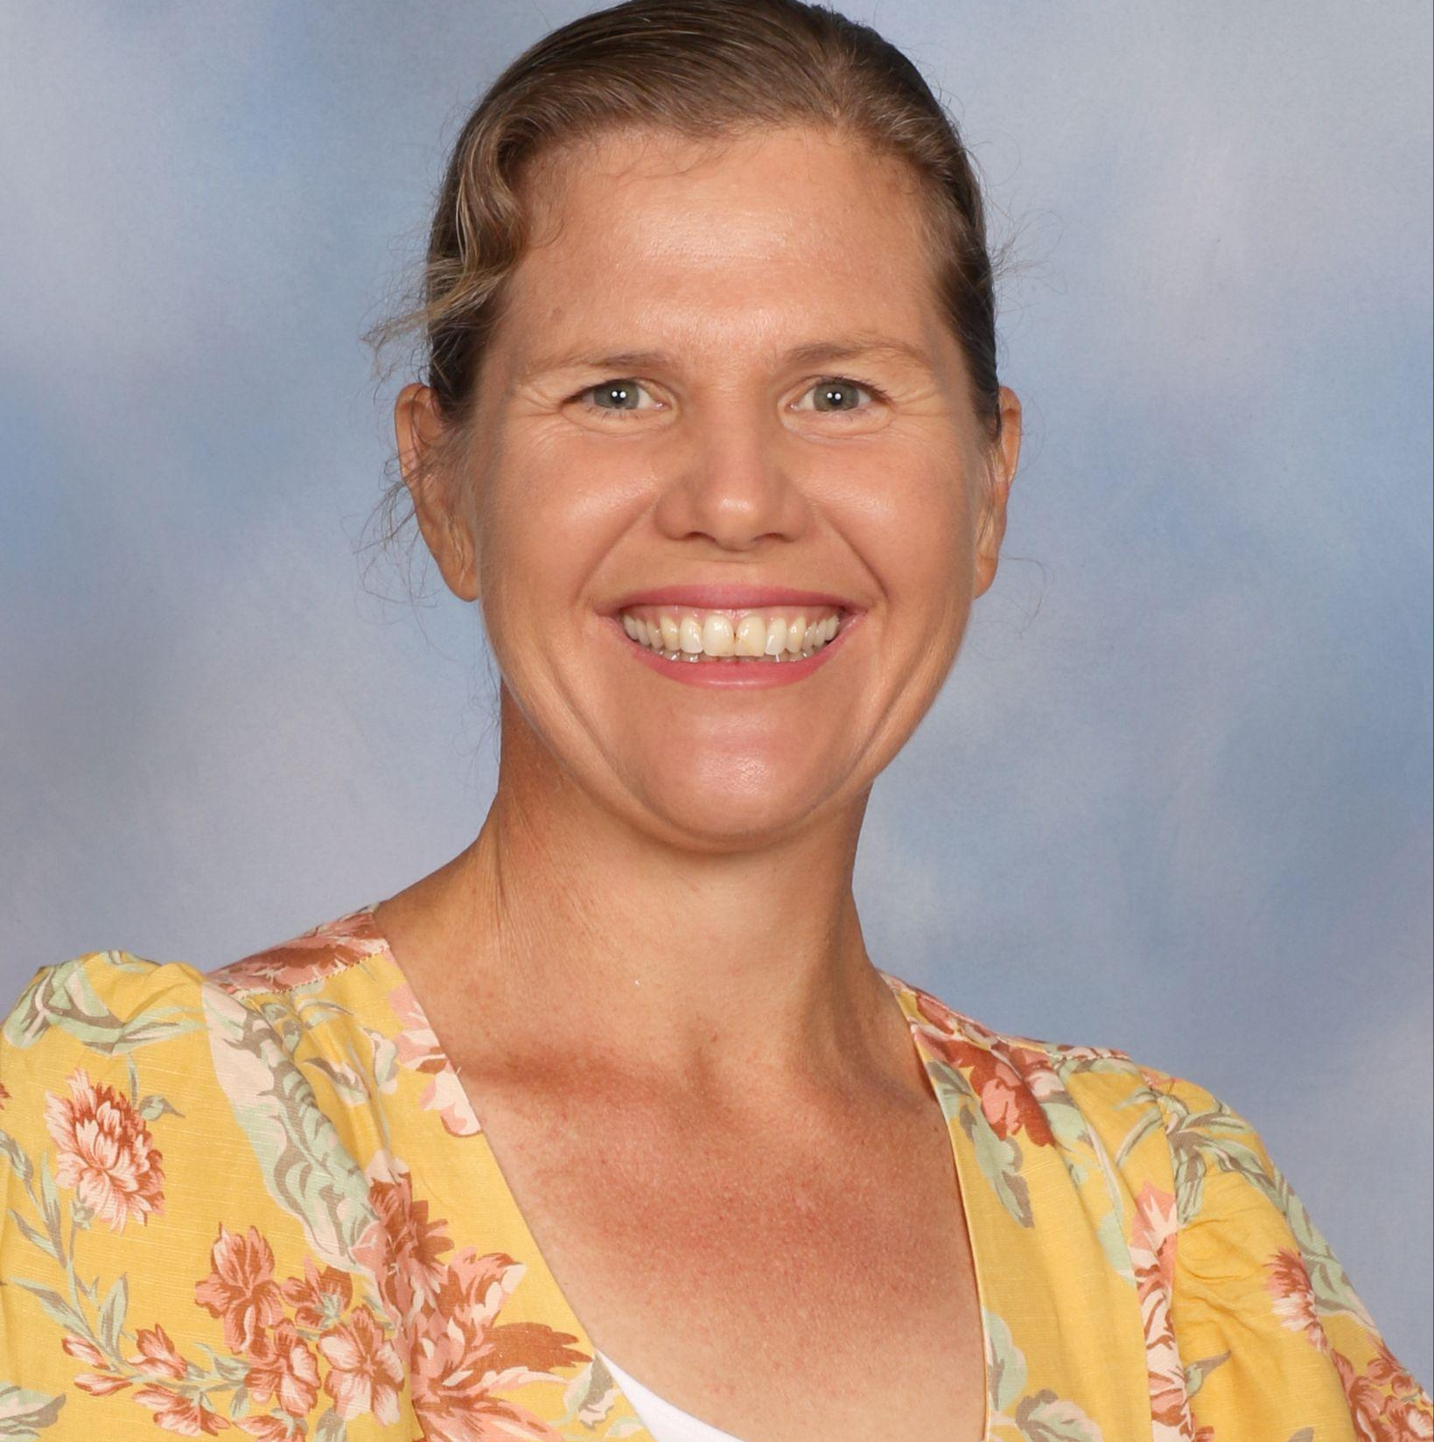 | 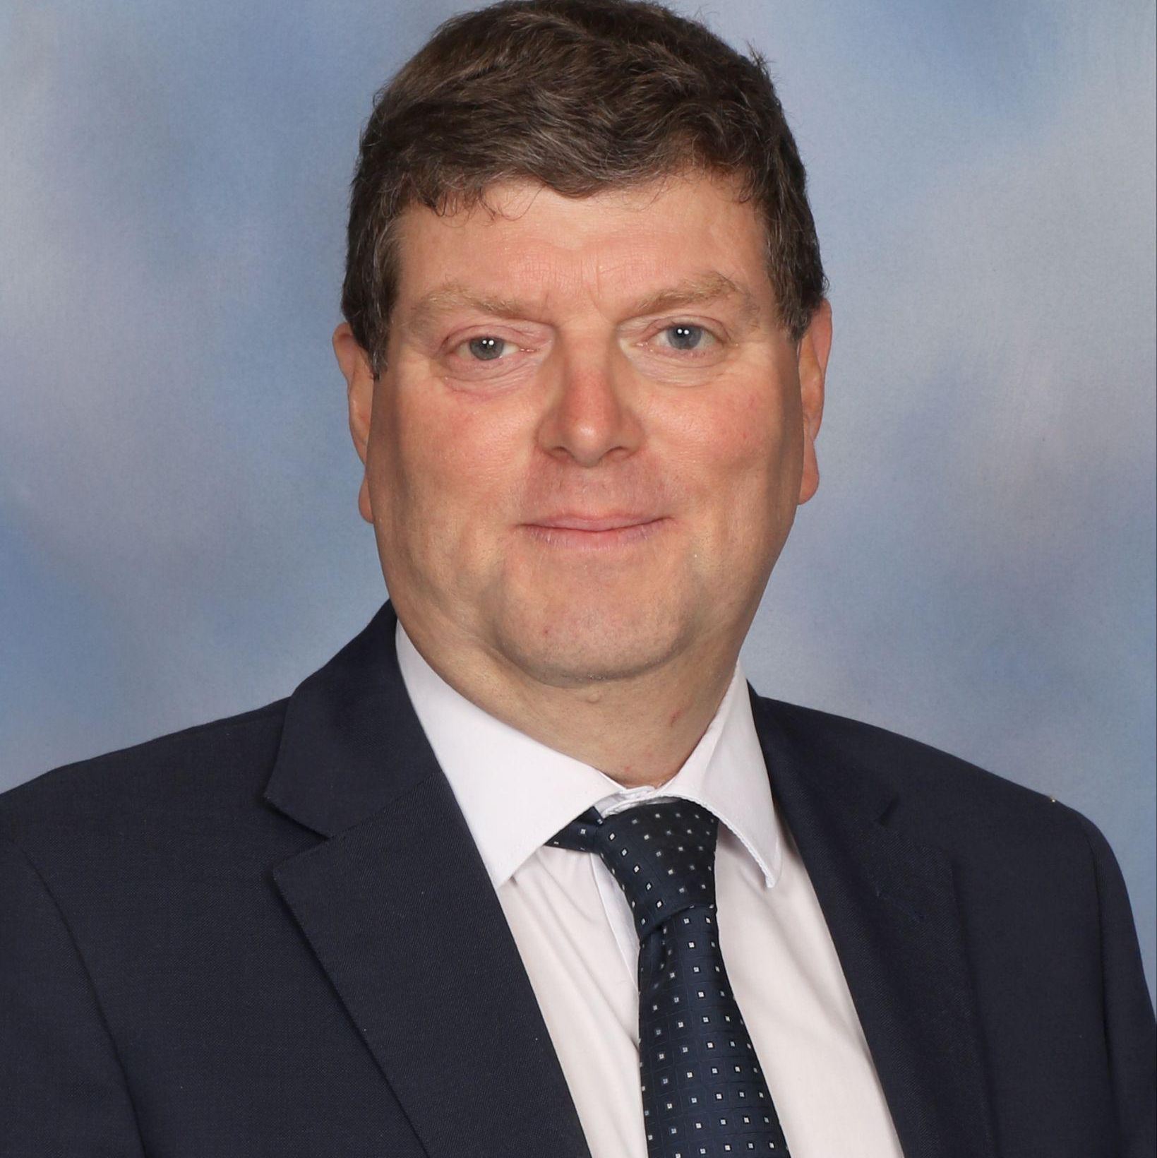 | 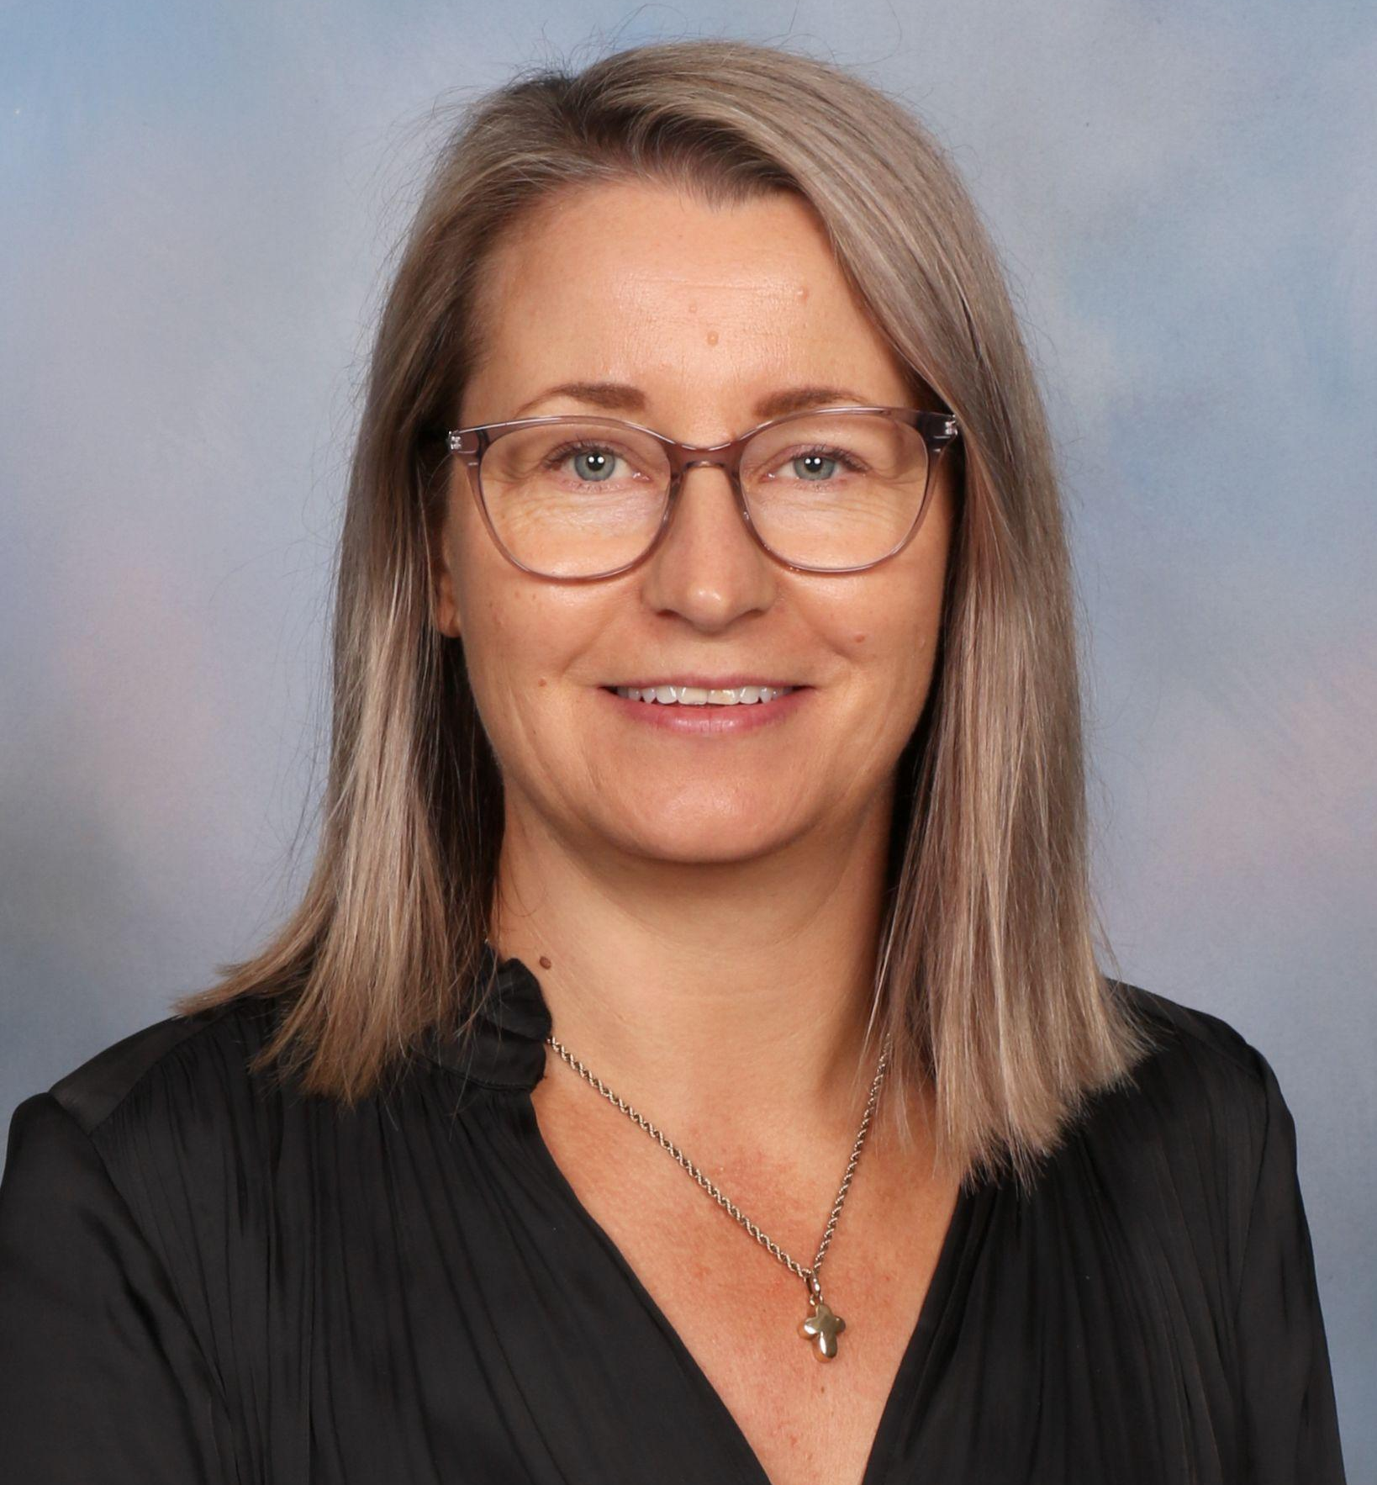
Cathy Speedy  International Coordinator  Ph: +64 3 578 0626  E: international@rvs.school.nz | Mr. Tom Jarrett  Principal  Ph: +64 3 578 0626  E: principal@rvs.school.nz | Mrs. Susie Johnson  Office Manager  Ph: +64 3 578 0626  E: office@rvs.school.nz

Support services

Counselling and Wellbeing, Guidance Counsellor
Richmond View School has two part-time counsellors, Mr. Alistair Crawford, who is a member of the New Zealand Association of Counsellors and Mrs. Rosemary Crockett, who holds a provisional membership with NZCCA (New Zealand Christian Counsellors Association. Students are offered a confidential and professional service. Students can be seen individually or in small groups.

APPLICATION PROCESS AND REQUIREMENTS
Complete our online International Students Application Form and Enrolment Agreement. Include all necessary documents with this application.
- Student Interview: The student will be invited for an interview, either in person or online, this will be with our school representatives. This meeting takes around 15 to 20 minutes. The purpose of the meeting is to get to know the student and understand what their interests and goals are. A pre-entry English test may also be required.
- Offer of Place and invoice from the school are sent to successful applicants.
- On full payment of fees, the school will send a fee receipt to the family.
- Apply for a student visa. You can find comprehensive visa requirements from Immigration New Zealand.
VISAS AND IMMIGRATION
Full details of visa and permit requirements, advice on rights to employment in New Zealand while studying, and reporting requirements are available through Immigration New Zealand and can be viewed here or
https://www.immigration.govt.nz/
Student visa checklists can be viewed here or
https://www.immigration.govt.nz/assist-migrants-and-students/assist-students/student-visa-info
- Provide the school with evidence that you have obtained appropriate Medical and Travel insurance.
- Orientation Information is sent to the student prior to starting their study with the dates they are required to attend, and what to expect. Orientation is fun and includes activities. You will meet other students and your buddy (a senior student) who will help you familiarise yourself with our school campus.
- After arriving in Blenheim, acquire your school uniform and stationery kit from the school office.
- Attend Orientation and commence your study.

FEES FOR INTERNATIONAL STUDENTS

International fee schedule 2025
Please note: All costs are quoted in New Zealand Dollars and include GST (Goods and Services Tax) where required. Costs relate to 2025; pricing may be subject to change for 2026.

$17,500.00 Tuition Fee ($4,375 per term)
$300 Application Fee (non-refundable)
$1,100.00 Administration Fee
$300 Homestay Placement Fee
$365.00 per week Homestay Fees ($17,155 per year)
$700.00 Insurance - Health & Travel (approximate cost)
$383.30 NCEA/Exam Fee (only for Year 11-13 students)
$1,200.00 per year Student Care/Pastoral Fee
(or $300.00 per term)

Bulk Uniform Purchase Fee
Junior School:
- Boys $770
- Girls $835
Senior School:
- Boys $1,305
- Girls $1,235
Middle School:
- Boys $1,010
- Girls $950

Additional Expenses:
Stationery Pack: subject dependent TBC (please provide your own laptop - Middle and Senior students only)
Additional Activities: $1,000 (reimbursed if not used)

Notes to the Schedule of Fees 2025:
Student Care Fees: Richmond View School provides high-quality pastoral care and support for all students. Student care fees cover the cost of orientation, monitoring and continuous support for our students and the liaison with their homestay, care providers and designated caregivers. All students, regardless of who they live with, will be charged a Student Care Fee.

Insurance: The school will obtain insurance from Student Safe.
https://www.insurancesafenz.com/studentsafe/student-safe-inbound-learners

HELPFUL LINKS
Richmond View School’s website
https://www.rvs.school.nz/

Richmond View School policies:
International Student Policies
All other School Policies and Procedures

Richmond View’s most recent ERO report
https://ero.govt.nz/institution/421/richmond-view-school

Cost of living in New Zealand | NauMai NZ
Information and suggestions to help those new to New Zealand find your way, connect and explore New Zealand
studywithnewzealand.govt.nz

Tourism New Zealand
Tourism New Zealand offers some valuable information about tourism opportunities for families while in New Zealand.
tourismnewzealand.com

100% Pure New Zealand
100% Pure New Zealand offers some valuable suggestions and information about tourism opportunities for families while in New Zealand​​​​​​​
newzealand.com

Tuition fees and cost of living
Information on Tuition fees and cost of living in New Zealand
Study with New Zealand

NZQA's Studying in New Zealand
This site offers further information about New Zealand qualifications, secondary school and NCEA, Tertiary education and quality assurance of education in New Zealand.
nzqa.govt.nz

Students travelling to New Zealand
This site offers information for students to help them plan their move to New Zealand and to settle quickly once they get here. It also offers information about visa options for students and families.
immigration.govt.nz

New Zealand Now
This Government website shares information about living, working, studying and investing in New Zealand, as well as information about visas, job prospects and the great lifestyle here.
www.newzealandnow.govt.nz

Education New Zealand
Education New Zealand (ENZ) raises awareness of New Zealand as a study destination and supports education providers and businesses to export their services and products.
enz.govt.nz

Richmond View School, complaint process
This process is to support students if they have a problem and are unsure who to talk with at school.
RVS complaint process.

Disputes Resolution Scheme
The DRS is a free service that supports students to resolve complaints with their education provider.​​​​​​​
https://www.istudent.org.nz/

Richmond View School, information on student wellbeing
Read more here.​​​​​​​

Live & Work in Marlborough
Guide for parents accompanying their son/daughter and living in Marlborough.
https://marlboroughnz.com/live-work/



